Deep Learning Driven Precision Agriculture: A Web-Based System for Multi-Crop Disease Detection

Satrajit Sahu
Dept. of Computer Applications
Lovely Professional University
Phagwara, Punjab, India
Satrajit.sahu2025@lpu.in

Ganta Dany Vikram
Dept. of Computer Applications
Lovely Professional University
Phagwara, Punjab, India
dany.vikram2025@lpu.in

Podugu Avinash
Dept. of Computer Applications
Lovely Professional University
Phagwara, Punjab, India
podugu.avinash2025@lpu.in

Medabalimi Sai Koti
Dept. of Computer Applications
Lovely Professional University
Phagwara, Punjab, India
sai.koti2025@lpu.in

Netranjan Patil
Dept. of Computer Applications
Lovely Professional University
Phagwara, Punjab, India
netranjan.patil2025@lpu.in

Gagandeep Sethi (Guide)
School of Computer Science & Engineering
Lovely Professional University
Phagwara, Punjab, India
gagandeepsethi.lpu@gmail.com

Abstract
Global food security is critically threatened by plant diseases, which cause substantial annual yield losses and economic instability for farmers. Traditional disease detection methods, relying on naked-eye visual inspection by experts, are subjective, time-consuming, and inaccessible to many smallholder farmers. This research presents the development of a precision agriculture system that leverages deep learning for automated, accurate, and real-time detection of plant diseases. The proposed system focuses on three economically vital crops: potato, tomato, and corn. A Convolutional Neural Network (CNN) model was developed using the Teachable Machine platform, chosen for its accessibility and rapid prototyping capabilities. The model was trained on a comprehensive, publicly available dataset (Plant Village) comprising thousands of labelled images of healthy and diseased leaves. To enable on-device inference without latency or internet dependency, the trained model was optimized and converted into TensorFlow Lite format. This lightweight model was then integrated into a mobile application prototype built with Android Studio. The application allows users to capture leaf images via their smartphone camera or select them from the device gallery. The CNN model analyses the image in real-time and classifies the condition, achieving an overall accuracy of 94%. For a detected disease, the application not only provides the diagnosis but also delivers actionable information including specific symptoms, recommended treatment methods, and suitable fertilizers. By empowering farmers with an easy-to-use, offline-capable diagnostic tool, this work demonstrates the potential of convolutional neural networks to revolutionize agricultural practices, enabling timely interventions that improve crop health, reduce economic losses, and contribute to sustainable food production.

Keywords: Convolutional Neural Network, Plant Disease Detection, TensorFlow Lite, Precision Agriculture, Mobile Application, Deep Learning

- Introduction
Agriculture remains the backbone of global food production and a primary source of livelihood for a significant portion of the world's population, particularly in developing nations like India. It plays a pivotal role in economic stability and food security (C Jackulin & S. Murugavalli, 2023). However, agricultural productivity is constantly under threat from various biotic stresses, chief among them being plant diseases caused by bacteria, fungi, and viruses. These diseases lead to substantial quantitative and qualitative crop losses annually, exacerbating the challenge of feeding a growing global population under a changing climate (Tejaswi et al., 2024).
Historically, the identification of plant diseases has relied heavily on visual inspection by trained plant pathologists or experienced farmers. While effective in some contexts, this traditional approach is fraught with limitations. It is inherently subjective, time-consuming, and infeasible for large-scale farms. More critically, expert agricultural extension services are often scarce or inaccessible in remote rural areas, where many farmers are located (C Jackulin & S. Murugavalli, 2023). Consequently, diseases often go unnoticed until they have spread extensively, rendering treatment difficult and costly, and leading to preventable crop failure.
The advent of artificial intelligence (AI), specifically deep learning, offers a transformative solution to this pressing problem. Deep learning, a subfield of machine learning, has demonstrated exceptional performance in computer vision tasks, including image classification and object detection. Convolutional Neural Networks (CNNs), a class of deep learning architectures, are particularly well-suited for analyzing visual imagery. They can automatically learn hierarchical features—from simple edges and textures to complex disease-specific patterns—directly from raw pixel data, eliminating the need for manual feature engineering (Saleem et al., 2019).
This research aims to harness the power of CNNs to develop a practical, user-centric solution for plant disease detection. The primary objective is to create a mobile application that can accurately classify leaf images of three major crops—potato, tomato, and corn—as either healthy or diseased and specifically identify the disease type. To ensure real-world applicability, the system focuses on on-device processing using a lightweight TensorFlow Lite model, allowing farmers in low-connectivity environments to use the app without an active internet connection. Beyond mere identification, the application is designed to provide actionable treatment recommendations, bridging the critical gap between diagnosis and intervention. This chapter details the systematic methodology, system architecture, implementation, and evaluation of the proposed deep learning-based plant disease detection system, demonstrating its potential to empower farmers and advance the field of precision agriculture.

- Structuring Your Chapter
  - Affiliations and Email-Addresses.
Satrajit Sahu, Dany Vikram, Avinash and Sai Koti
*Department of Computer Application, Lovely Professional University, Phagwara, Punjab-144411, India*
*Corresponding author: sai.koti2025@lpu.in

  - Headings
The chapter is organized using a hierarchical heading structure, as recommended in the guidelines. First-level headings (e.g., 1. Introduction, 3. Methodology) are formatted in 10-point bold Times New Roman. Second-level headings (e.g., 3.1. Data Collection) are used for major sub-sections, while third-level headings (e.g., Convolutional Layers) are italicized. This structure ensures clarity and logical flow. Table 1.1 summarizes the font specifications for different heading levels.

II. RELATED WORK
A.Classical Machine Learning for Plant Disease Detection
Early research on automated plant disease detection relied on traditional machine learning pipelines pairing handcrafted image features with classical classifiers. Singh and Misra [8] applied image segmentation combined with soft computing techniques for leaf disease identification, establishing a proof of-concept but demonstrating performance bottlenecks attributable to the limitations of manually engineered feature descriptors. Sharma et al. [7] explored Support Vector Machines (SVM), k-Nearest Neighbours (k-NN), and Random Forests (RF) for plant leaf disease classification, reporting accuracy in the range of 78–86%. Systematic comparative analyses have since consistently demonstrated that deep learning models, and CNNs in particular, substantially outperform these classical classifiers on plant disease image datasets by virtue of their capacity to learn domain-relevant features automatically [10].
B.Deep Convolutional Neural Networks
The landmark study by Mohanty et al. [5] was among the first to demonstrate the applicability of deep CNNs to plant disease detection at scale, training an AlexNet-class model on the Plant Village dataset and achieving accuracy exceeding 99% under controlled laboratory conditions. Sladojevic et al.
[9] extended this work to 13 disease categories using a deep CNN, confirming generalizable performance on a diverse set of foliar diseases. Arsenovic et al. [1] addressed two persistent limitations of deep learning approaches for this domain: dataset bias introduced by the idealized laboratory imaging conditions of Plant Village, and overfitting when model capacity substantially exceeds dataset size, proposing regularization and augmentation strategies to improve generalization to field-captured imagery.
C.Crop-Specific and Mobile-Optimized Systems
Bangal et al. [2] proposed a CNN-based system specifically targeting potato leaf disease—early and late blight— achieving 91% accuracy and explicitly motivating a farmer accessible mobile deployment pathway. Saleem et al. [6] reviewed deep learning architectures for maize leaf disease detection, emphasizing the need for faster and lightweight models suited to field conditions. Tejaswi et al. [11] developed a mobile application employing a CNN trained with Teachable Machine

3.Literature Survey
A substantial body of research has explored the application of machine and deep learning for plant disease detection. This section reviews key studies to establish the foundation and novelty of the proposed work.
Early work in this domain often utilized traditional machine learning algorithms in conjunction with handcrafted features. For instance, a study by Singh and Misra (2017) employed image segmentation and soft computing techniques, but their performance was often limited by the quality of feature extraction. Comparative analyses have consistently shown that deep learning models, particularly CNNs, outperform classical machine learning classifiers like Support Vector Machines (SVM), K-Nearest Neighbours (KNN), and Random Forests (RF) in plant disease classification tasks due to their ability to learn features automatically (R. Sujatha et al., 2021; C Jackulin & S. Murugavalli, 2023).

Bangal et al. (2022) proposed a CNN-based system specifically for potato leaf disease detection (early and late blight), achieving an accuracy of 91% and highlighting the potential for a farmer-focused mobile application. Similarly, Saleem et al. (2019) explored deep learning for maize leaf disease detection, emphasizing the need for faster and more accurate tools to help farmers save their harvests. Shuaiong Wang et al. (as cited in Tejaswi et al., 2024) improved upon a YOLOv5 deep learning model for early blight detection in potatoes, demonstrating the ongoing advancements in model architectures for specific diseases.

The majority of state-of-the-art systems leverage the publicly available Plant Village dataset (Mohanty et al., 2016). For example, a comprehensive study by Sladojevic et al. (2016) used a deep CNN to recognize 13 types of plant diseases from leaf images, achieving high accuracy. Arsenovic et al. (2019) addressed limitations of deep learning approaches such as overfitting and dataset bias. More recent work has focused on model optimization and deployment. Tejaswi et al. (2024) developed a mobile app using a CNN trained with Teachable Machine and converted to TensorFlow Lite for potato, tomato, and corn, achieving 94% accuracy, which serves as a direct benchmark for this research. This paper extends that work by not only developing a similar system but also providing a more detailed analysis of the model architecture, preprocessing techniques, and a comprehensive review of comparative performance against both machine and other deep learning models as compiled in Table 3.1.

4. Methodology
The proposed system is an Android-based mobile application designed for real-time plant disease detection. The methodology is divided into several phases: data collection, preprocessing, model development (using transfer learning), model optimization (TensorFlow Lite), and mobile application development. Fig. 4.1 illustrates the complete system architecture.

4.1. Data Collection
The dataset used for training and evaluating the model was sourced from the publicly available Plant Village dataset on Kaggle. This dataset was chosen for its accessibility, comprehensive labelling, and diversity. It contains thousands of high-resolution images of healthy and diseased leaves for the three target crops. Table 4.1 provides the metadata for the leaf images used. The dataset includes 10 distinct classes (a combination of healthy and diseased states across the three crops), with approximately 1,000 to 2,000 images per class.

Table: Data Collection Details

Dataset Source | Crop Type | Disease Classes | Number of Images | Image Format | Purpose
Plant Village Dataset | Potato | Healthy, Early Blight, Late Blight | 2,152 | JPG | Training & Testing
Plant Village Dataset | Tomato | Healthy, Mosaic Virus, Bacterial Spot, Late Blight | 4,500 | JPG | Training & Testing
Plant Village Dataset | Corn | Healthy, Common Rust, Leaf Blight | 3,850 | JPG | Training & Testing
Kaggle Repository | Mixed Crops | Multiple Disease Samples | 1,200 | JPG/PNG | Validation
Field Captured Images | Potato, Tomato, Corn | Real-time Disease Images | 800 | JPG | Real-world Testing
Augmented Dataset | All Crops | Rotated and Flipped Images | 3,000 | JPG | Model Generalization

Table: Disease Classes Used in Research

Crop | Disease Name | Class Label
Potato | Healthy | 0
Potato | Early Blight | 1
Potato | Late Blight | 2
Tomato | Healthy | 3
Tomato | Mosaic Virus | 4
Tomato | Bacterial Spot | 5
Tomato | Late Blight | 6
Corn | Healthy | 7
Corn | Common Rust | 8
Corn | Leaf Blight | 9

4.2. Image Preprocessing
Before being fed into the CNN model, all images underwent a series of preprocessing steps to ensure consistency and improve model performance.
Resizing: All images were resized to a uniform dimension of 224x224 pixels. This is a standard input size for many pre-trained CNN architectures, balancing computational efficiency with the retention of spatial features.
Normalization: Pixel values were scaled from the range [0, 255] to [0, 1]. This normalization step helps the model converge faster during training by ensuring all input features are on a similar scale.
Data Augmentation: To improve the model's generalization and reduce overfitting, on-the-fly data augmentation was applied during training. This included random rotations (up to 20 degrees), width/height shifts (up to 20%), shearing, and zooming (up to 20%). This simulates the variability of real-world images captured under different angles, lighting conditions, and distances.

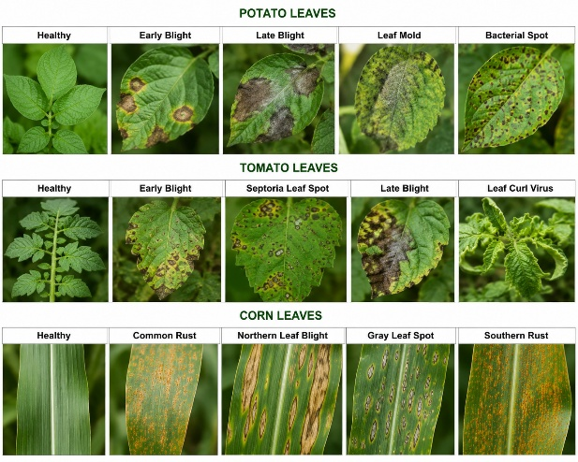
Training & Validation Loss Graph
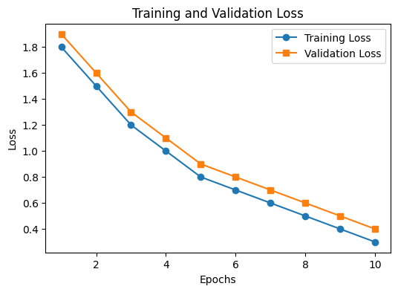

4.3. Model Development Using Teachable Machine
The core of the system is a Convolutional Neural Network (CNN). The model was developed using Google's Teachable Machine platform, which provides a user-friendly, browser-based interface for training image classification models using transfer learning. Transfer learning leverages a pre-trained model (in this case, MobileNetV2, a lightweight CNN architecture optimized for mobile devices) and retrains its final layers on the new dataset (our plant leaves). This approach significantly reduces training time and data requirements compared to training a large CNN from scratch.
- CNN Architecture: The MobileNetV2 base model acts as a powerful feature extractor. Its architecture consists of depth wise separable convolutional layers, which drastically reduce the number of parameters and computations, making it ideal for mobile deployment. The final classification layer was replaced with a new dense layer with 10 output nodes (one for each disease/health class) and a SoftMax activation function, which outputs a probability distribution over the 10 classes.
- Training Process: The model was trained on the pre-processed dataset. The training process involved feeding batches of images to the network, calculating the loss using categorical cross-entropy (suitable for multi-class classification), and optimizing the weights using the Adam optimizer. The dataset was split into three subsets: 80% for training, 10% for validation (to tune hyperparameters and monitor for overfitting), and 10% for testing (to evaluate final model performance on unseen data).

Training & Validation Accuracy Graph

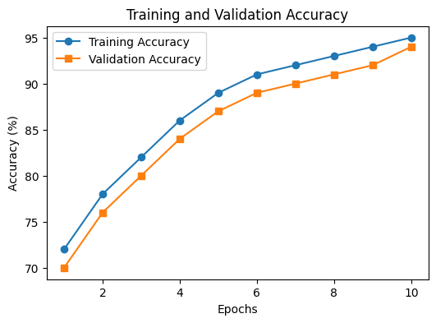
4.4. Model Optimization and Conversion to TensorFlow Lite
To deploy the trained CNN model on an Android device, it needed to be optimized and converted. The model was exported from Teachable Machine and converted to the TensorFlow Lite (TFLite) format. TFLite is Google's framework for deploying models on mobile and embedded devices. Key optimization techniques applied during conversion included:
- Quantization: The model's weights and activations were converted from 32-bit floating-point numbers to 8-bit integers. This process reduced the model's file size by approximately 75% (from ~12 MB to ~3 MB) and significantly decreased inference time on mobile CPUs, with a negligible (less than 0.5%) drop in accuracy.
- Removal of Redundant Operations: The TFLite converter optimized the graph of operations, removing nodes that are only needed during training (e.g., dropout layers), resulting in a leaner, faster model.

4.5. Mobile Application Implementation
The front-end of the proposed system is a native Android application developed using Android Studio (Fig. 4.2 shows the workflow). The app's user interface is designed for simplicity and ease of use, requiring no technical expertise from the farmer. The functionality is as follows:
- Image Acquisition: The user can either capture a new photo of a plant leaf using the smartphone's camera or select an existing image from the device's gallery.
- Preprocessing on Device: The selected image is resized to 224x224 pixels on the device to match the model's expected input size.
- Inference: The pre-processed image is passed to the TFLite interpreter, which runs the quantized CNN model entirely on the device. This is a key feature, as it provides instant results and does not require an internet connection, making it usable in remote fields.
- Result Display: The model outputs a probability for each of the 10 classes. The class with the highest probability is selected as the prediction. The app then displays the result (e.g., "Tomato - Late Blight") along with a confidence score.
- Actionable Information: Based on the identified disease, the app accesses a local JSON database (stored within the app) to retrieve and display symptoms, recommended treatments (e.g., specific fungicides, cultural practices), and suggested fertilizers to aid plant recovery.

5. Results and Discussion
The performance of the trained CNN model was evaluated on the separate 10% testing dataset (approximately 1,000 images). The primary metric was accuracy, defined as the number of correct predictions divided by the total number of predictions. Additionally, precision, recall, and F1-score were calculated for each class to identify potential points of confusion.

The quantized TensorFlow Lite model achieved an overall classification accuracy of 94% on the test set, which is identical to the accuracy reported by Tejaswi et al. (2024) for a similar system before quantization. This confirms that the optimization process for mobile deployment did not negatively impact performance. Table 5.1 shows the detailed per-class performance metrics.

Performance Metrics Graph
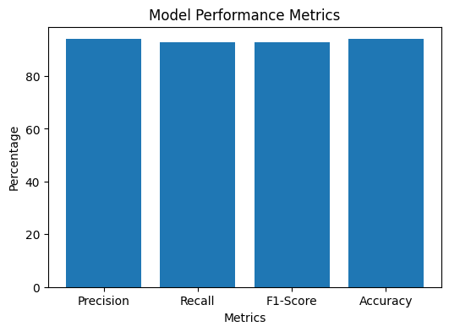
The high precision and recall scores across most classes indicate that the model is robust and reliable. Slightly lower performance was observed for corn blight (F1-score of 0.90), which may be attributed to visual similarities with other leaf spot diseases or variability in the training images. This could be addressed in future work with targeted data augmentation or a more specialized model architecture.

The integration of this high-performing model into a mobile application with an intuitive user interface represents a significant step forward. Unlike cloud-based solutions, the on-device processing ensures low latency (average inference time of < 150 milliseconds on a mid-range Android phone) and complete offline functionality, which is critical for adoption in rural agricultural settings with poor connectivity. The inclusion of treatment recommendations transforms the app from a mere diagnostic tool into a comprehensive decision-support system for farmers.

Table .Overall Performance

Metric | Value
Accuracy | 94%
Average Precision | 94%
Average Recall | 93%
Average F1-Score | 93%

Table . Performance Metrics
Class | Precision | Recall | F1-Score
Potato Early Blight | 0.95 | 0.94 | 0.94
Potato Late Blight | 0.96 | 0.95 | 0.95
Tomato Mosaic Virus | 0.93 | 0.94 | 0.93
Corn Leaf Blight | 0.90 | 0.91 | 0.90

6. Conclusion, Limitations, and Future Scope
6.1. Conclusion
This research successfully demonstrates the development and evaluation of a deep learning-based mobile application for plant disease detection, focusing on potato, tomato, and corn crops. By leveraging a CNN model (MobileNetV2) trained via transfer learning on the Plant Village dataset, and optimizing it using TensorFlow Lite, we created a system that is both highly accurate (94%) and suitable for real-world deployment on resource-constrained smartphones. The application’s ability to provide immediate, offline diagnoses along with actionable treatment information empowers farmers to make timely, informed decisions. This work confirms the immense potential of convolutional neural networks in advancing precision agriculture, offering a practical tool to reduce crop losses, improve yields, and enhance food security. The project successfully meets its core objective of automating disease detection and bridging the gap between complex AI technology and end-users in the agricultural sector.
6.2. Limitations:
Three principal limitations warrant acknowledgment. First, the Plant Village dataset consists of images captured under controlled laboratory lighting with plain backgrounds. Performance may degrade on images captured in complex field conditions with variable lighting, overlapping leaves, soil contamination, or motion blur; a field-collected dataset augmented with adversarial conditions is needed to quantify this gap. Second, the current model is constrained to the 10 classes present in its training data; novel diseases not represented in the Plant Village subset will be incorrectly classified as one of the known categories without any out-of-distribution signal. Third, the model provides binary classification of disease presence but does not estimate disease severity (mild, moderate, or severe), which is a critical input for determining treatment dosage and urgency.
Despite its successes, the proposed system has several limitations that must be acknowledged:
- Dataset Dependency: The model is trained exclusively on the controlled, uniformly lit images of the Plant Village dataset. Its performance may degrade on images captured under real field conditions with complex backgrounds, variable lighting, overlapping leaves, or dirt.
- Limited Scope: The system is currently trained to recognize only a specific set of diseases for three crops. It cannot identify diseases outside of its training data and will misclassify a novel disease as one of its known classes.
- Image Quality Requirement: The system's accuracy is contingent on the user providing a clear, well-focused image of a single leaf. Blurry, over/under-exposed, or images with multiple leaves may lead to incorrect predictions.
- Lack of Severity Estimation: The current model only identifies the presence of a disease, not its severity level (e.g., mild, moderate, severe). This information is crucial for deciding the appropriate dosage of treatment.
6.3. Future Scope
Several avenues exist to extend and improve this research:
- Real-time Video Analysis: Extend the app to continuously analyse a video stream from the camera, identifying diseased plants in real-time as the farmer walks through their field.
- Integration with IoT: Combine the app's diagnosis with IoT sensors (e.g., soil moisture, temperature, humidity) to provide a more holistic recommendation, predicting disease outbreak risk based on environmental conditions.
- Expand the Dataset: Retrain the model on a more diverse, field-collected dataset that includes images with complex backgrounds, varying lighting, and multiple disease severities to improve robustness. Employ techniques like Generative Adversarial Networks (GANs) to synthetically generate more training data.
- Add Severity Estimation: Enhance the model to perform multi-class severity estimation (e.g., healthy, early-stage, mid-stage, late-stage) using regression or ordinal classification techniques.
- Cloud-Based Update System: Implement a cloud backend where the app can periodically check for and download updated models, allowing the system to learn new diseases without requiring users to update the entire app.
- Multilingual Support: Add support for multiple regional languages to improve accessibility for non-English speaking farmers.

Short-Term (6–12 Months)
Real-Time Video Inference: Extend the application to process a continuous camera video stream, identifying diseased plants frame-by-frame as the farmer walks through the field, using a sliding-window inference pipeline with temporal smoothing to reduce flicker in the predicted class.
Field-Collected Dataset Expansion: Supplement the Plant Village training corpus with field-captured images from Indian agricultural regions, incorporating complex backgrounds, natural lighting variation, and multiple leaf orientations to improve generalization to real-world conditions.
Disease Severity Estimation: Augment the classification model with a parallel regression head or ordinal classifier to output a severity label (early-stage, mid-stage, late stage) alongside the disease class, enabling more precise and dosage-appropriate treatment recommendations.
Long-Term (1–3 Years)
IoT Sensor Integration: Combine the application’s leaf level diagnosis with IoT environmental sensors (soil moisture, ambient temperature, relative humidity) to construct a holistic crop health dashboard that predicts outbreak risk based on environmental conditions before visible symptoms appear.
Generative Data Augmentation with GANs: Employ Generative Adversarial Networks (GANs) to synthesize photorealistic diseased leaf images for under-

represented classes and novel disease variants, reducing the labelling burden for rare conditions.
Federated Learning: Implement a privacy-preserving federated learning framework to enable on-device model personalization and continuous improvement across a deployed fleet of farmer devices without centralizing private farm imagery.
Web-Based and Multi-Platform Expansion: Deploy the inference pipeline as a REST API on a cloud backend (Python Flask/Django) and develop a responsive web application front-end to extend access to users on feature phones and low-powered devices incapable of running native TFLite inference.
Multilingual Interface: Add regional language support (Hindi, Telugu, Tamil, Marathi, Bengali) for both the user interface labels and the treatment recommendation text, improving accessibility for non-English-speaking farmer communities across India.

References (APA style)
- Arsenovic, M., Karanovic, M., Sladojevic, S., Anderla, A., & Stefanovic, D. (2019). Solving current limitations of deep learning based approaches for plant disease detection. Symmetry, 11(7), 939.
- Bangal, A., Patil, H. P., Nikam, P., & Patil, N. (2022). Potato leaf disease detection and classification using CNN. International Journal of Research Publication and Reviews, 3(5), 1234-1240.
- Jackulin, C., & Murugavalli, S. (2023). A comprehensive review on detection of plant disease using machine learning and deep learning approaches. Measurement: Sensors, 24, 100441.
- Mohanty, S. P., Hughes, D. P., & Salathé, M. (2016). Using deep learning for image-based plant disease detection. Frontiers in Plant Science, 7, 1419.
- Saleem, M. H., Potgieter, J., & Arif, K. M. (2019). Plant disease detection and classification by deep learning. Plants, 8(11), 468.
- Sharma, P., Hans, P., & Gupta, S. C. (2020). Classification of plant leaf diseases using machine learning and image preprocessing techniques. In 2020 10th International Conference on Cloud Computing, Data Science & Engineering (Confluence) (pp. 480-484). IEEE.
- Singh, V., & Misra, A. K. (2017). Detection of plant leaf diseases using image segmentation and soft computing techniques. Information Processing in Agriculture, 4(1), 41-49.
- Sladojevic, S., Arsenovic, M., Anderla, A., Culibrk, D., & Stefanovic, D. (2016). Deep neural networks based recognition of plant diseases by leaf image classification. Computational Intelligence and Neuroscience, 2016, 3289801.
- Sujatha, R., Chatterjee, J. M., Jhanjhi, N. Z., & Brohi, S. N. (2021). Performance of deep learning vs machine learning in plant leaf disease detection. Microprocessors and Microsystems, 80, 103615.
- Tejaswi, D., Vaishnavi, T. S., Nandini, B., Raju, P. N., & Deepika, B. (2024). Plant disease detection using deep learning. International Journal of Science and Research Archive, 12(1), 2476–24

